**How to use OpenCV in Visual Studio**

[Video](https://www.youtube.com/watch?v=M-VHaLHC4XI)

**Part 1: Configure Windows**

* Open start menu, type ‘This PC’. Right-click the top result and select ‘Properties’

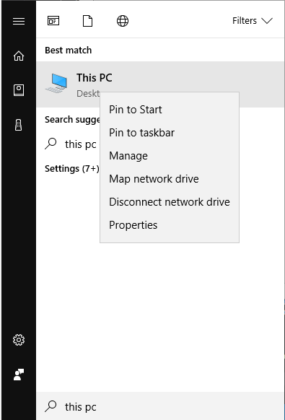

* On the left side of the window, select ‘Advanced system settings’
* Select ‘Environment Variables…’
* Double-click on the row labeled ‘Path’ 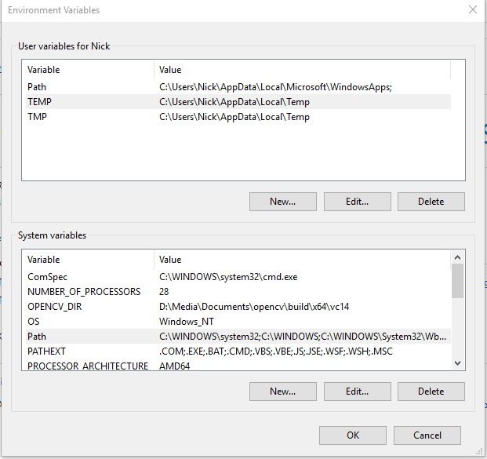
* Select ‘New’. In the textbox, paste the following directory:
* D:\Media\Documents\opencv\build\x64\vc14\bin
* (Note: This is my directory. You will have to navigate to the specified folder on your own computer and use that directory. The remaining directories in this guide will begin with …\opencv\ to reflect that.)

**Part 2: Configure Visual Studio**

- Make sure debugger is set to 64-bit



- Right-click project title in Solution Explorer, click ‘Properties’

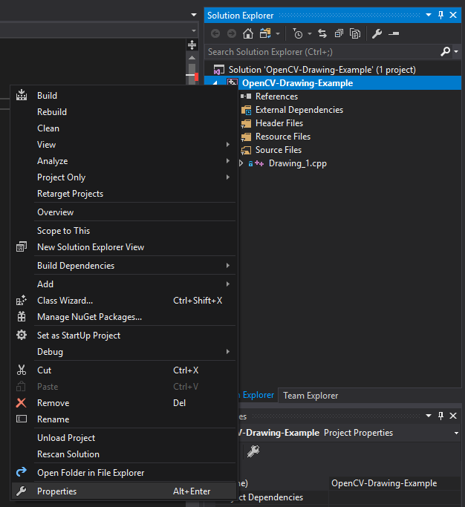

- Paste the following directory to “Additional Include Directories”:

…\**opencv\build\include**

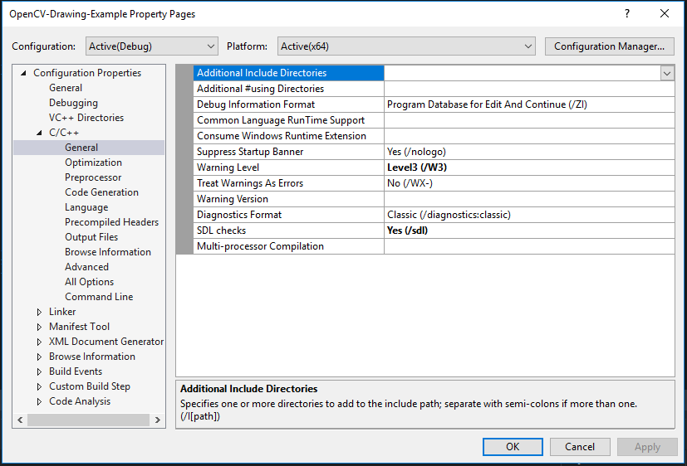

- Paste the following directory to “Additional library directories”:

…\**opencv\build\x64\vc14\lib**

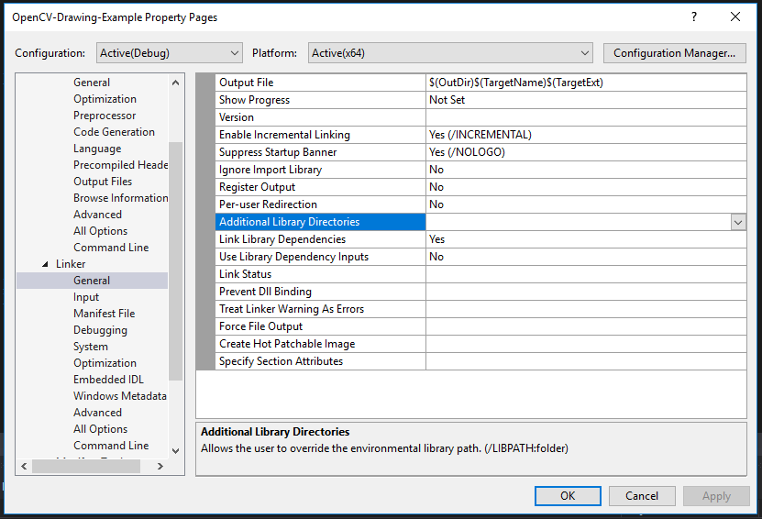

- Click the down-arrow on the right-end of “Additional Dependencies”

Paste the following file name in the text box below: **opencv_world330d.lib**

